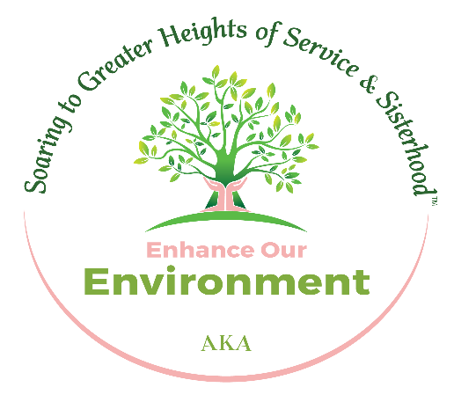

*Tau Epsilon Omega Chapter*

*June 2024 Enhance our Environment Committee Meeting*

*June 20, 2024, 8:00 PM*

*Zoom*

*https://us02web.zoom.us/j/9952637222?pwd=aldZa0t2a0ExTEdZUDhlZWRTeWlEQT09&omn=82697195911*

*Meeting ID: 995 263 7222*

*Passcode: pinkivy*

**__________________________________________________________________**

* + **Prayer & Welcome**
  + **Sub-Committee Updates (Tree Planting, Recycling, Waste Reduction & Gardening)**
  + **Fall & Winter Activities**
  + **Closing Meditation**